Identify trends on a price chart. Draw chart zones.
Entry Reasons. STEP1
- Align on the correct side of the market based around trend.
We do that by utilizing two time frames our first time frame, we needs to be one time frame up from the time frame we plan to trade on. The second time frame is the time frame we actually place the trade on.

2. Identify the trend and the last major swing level that was broken on the higher time frame, then draw a zone near that last level of resistance or last major swing.

3. Draw zone area: Zones are drawn between the highest bodies of the previous swing high and the highest wick of the previous swing high.
Wicks of candles can touch the zone area, bodies of candles can close in the zone area, the only thing that cannot happen is a candle closing above the zone area.
At the last major swing level that is broken on the higher time frame, before moving to the lower time frame, that is where you draw your zone.
STEP2.
3. Drop down to your actual trading time frame, wait on the market, asset, or whatever it is to come back up into the area or zone and then i want to see rejection.

4. Rejection: we are looking for the market to create a high, come to that high and then be rejected from it by Pushing lower this is known as a double top. It's extremely simple price pattern that i use for entry reasons. After the double top i want to see a red candle.
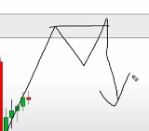

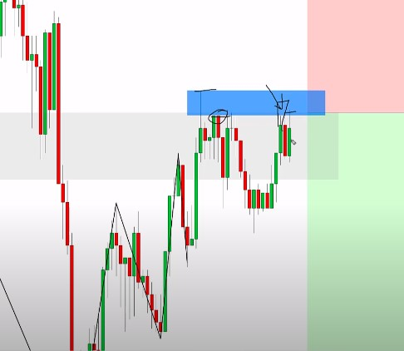
Rejection or Double top
Double top example

Bullish version.

If i'm trading on the 15 minute chart i want to look up at the one hour chart for my
1. Identify trend direction
2. Identify the major swing level that was broken last.

3. Identify the double bottom for a bullish trend

For a double bottom.
We have a push down, we have a bottom, we then have a neckline
We're looking for a retest of this area without closing below it that gives us buying pressure we then get a green candle followed by an even bigger green candle which is where our entry would be on that buying pressure candle for stop loss we would go below this low

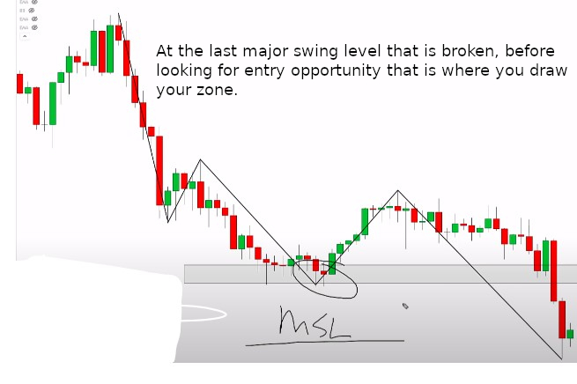

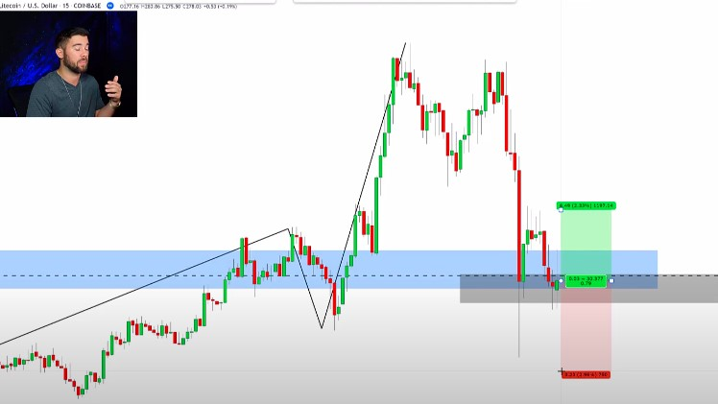
NOTE:
1. For a Rejection, we are looking for the market to create a high, come to that high and then be rejected from it by Pushing lower this is known as a double top.
2. Once a major swing level is broken that is the level you want to look at for trend continuation.
3. Zone area are drawn between the highest bodies of the previous swing high and the highest wick of the previous swing high.
Wicks of candles can touch the zone area, bodies of candles can close in the zone area, the only thing that cannot happen is a candle closing above the zone area.
At the last major swing level that is broken on the higher time frame, before moving to the lower time frame, that is where you draw your zone.
4. In a BULLISH trend, we are looking for a DOUBLE BOTTOM.
5. In a BEARISH trend, we are looking for a DOUBLE TOP

RULES FOR A DOUBLE TOP.
1. On retest, the wick must touch the top of the body of the previous structure.
2. The body of the retest cannot go above the wick of the previous structure.
RULES FOR A DOUBLE BOTTOM.
1. The lowest body of the candle this wick must touch.
2, The body of the retest, cannot close below the wick of the initial test.

